CSRA Neuromuscular Massage Clinic Intake Form

Your intake form is protected under HIPPA. The Privacy Rule is located at 45 CFR Part 160 and Subparts A and E of Part 164. At HHS.GOV

NAME: __________________________________________ DOB: ____________
ADDRESS: __________________________________________ PHONE (S) ____________
EMAIL: __________________________________________ REFERRED BY:
EMERGENCY CONTACT? ______________________________ ________________________

MAY I EMAIL OR TEXT YOU, MY SCHEDULE FOR FUTURE APPOINTMENTS? (YES) or (NO)

WHAT TECHNIQUE ARE YOU REQUESTING?
Therapeutic/Medical /Sports Massage______ Swedish/Relaxation ______ Prenatal Massage? What Term?_____
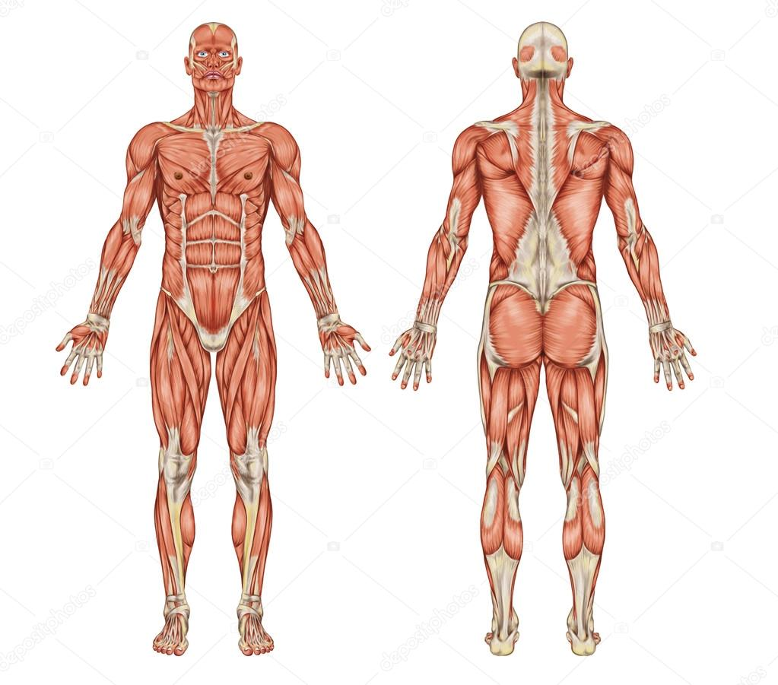

MEDICATIONS/SUPPLIMENTS: __________________________________________________________________
My concern is any fentanyl patches, blood thinners, nitro glycerin tablets, albuterol inhalers, muscle relaxers, chemo or radiation
PHYSICIAN’S CARE? __________________________________________________________________
FOR WHICH CONDITION (S)? __________________________________________________________________
ALLERGIES? __________________________________________________________________

- CSRA Neuromuscular Massage is an “IN-HOME Health Care Practice.” I am an Internationally Certified therapist with multiple and diverse credentials from Medical Massage and Fitness to Nutrition and Self-Management. I am NOT a physician that can diagnose. I AM, authorized within my scope of practice to give you my professional opinion as well as licensed to talk about Nutritional Kinesiology and I am also allowed to prescribe stretches under ISSA.

- I am prepared to speak with your physician at your request in regard to your treatment plan and in doing so will need your written request to include case-by-case insurance billing.

- This is a professional practice. Inappropriate behavior will not be tolerated and the session will close with payment remitted.

- Jennifer Ann Simpson, IANMT, CNMT, CMT, CFT, FT, RNRP, AKN, MMP is not liable for any injury or loss while on the premises of CSRA Neuromuscular Massage located at 3019 Pointewest Drive, Augusta, GA 30909.

Client signature: _________________________________________ date: _________________________
THERE IS A 3.00 CREDIT/DEBIT CHARGE & ALL APPS

